# Project Design Phase-II Data Flow Diagram & User Stories

|  |  |
| --- | --- |
| Date | 9 October 2022 |
| Team ID | PNT2022TMID25106 |
| Project Name | Crude Oil Price Prediction |
| Maximum Marks | 4 Marks |

Data Flow Diagrams:

A Data Flow Diagram (DFD) is a traditional visual representation of the information flows within a system. A neat and clear D FD can depict the right amount of the system requirement graphically. It shows how data enters and leaves the system, what changes the information, and where data is simplified

## Example: Simplifed EXAMPLE: DFD Level 0(Industry Standard)

Flow

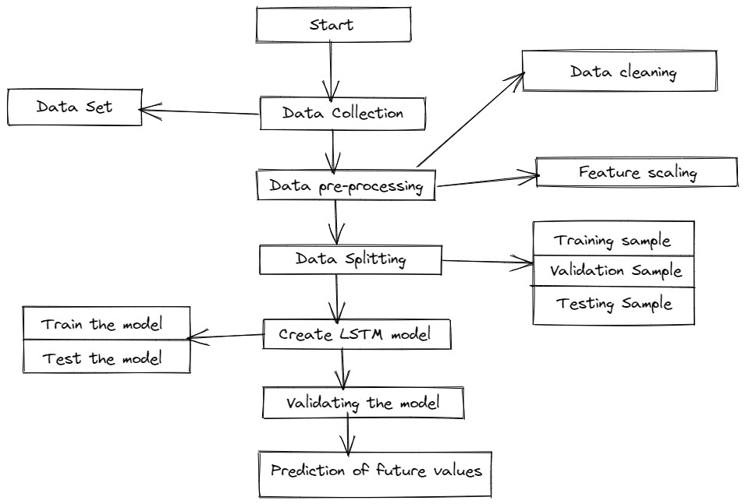

Scanned with OKEN Scanner

## **User Stories**

Use the below template to list all the user stories for the product.

|  |  |  |  |  |  |  |
| --- | --- | --- | --- | --- | --- | --- |
| User Type | Functional  Requirement  (Epic) | User Story Number | User Story / Task | Acceptance criteria | Priority | Retease |
| Customer (People) | Registration | USN-1 | Users can register for the application by entering their email address, and password, and confirming the password. | The account / dashboard can be accessed by me | High | Sprint-1 |
|  |  | USN-2 | Upon registration for the application, I will be able to do so using my Gmail account. | With my Gmail account, I am able to sign up for the dashboard and access it. | Medium | Sprint-2 |
|  | Login | USN-3 | My account can be accessed at any time by entering my email address and password, as I am a registered user. | My email address and password allow me to login to the site. | High | Sprint-1 |
|  | Historical data management | USN-4 | It is my responsibility as a user to split the dataset to be used for training and testing. | The dataset has been split into training and testing parts. | High | Sprint-1 |
|  | Model Building | USN-5 | It is my responsibility as a user to build a model and train the model. It is my responsibility to test the model to predict future prices. | We build the model, train it, and test it to make sure it is working well. | High | Sprint-1 |
| Administrator | Login | USN-1 | The Analysis page can be accessed by me as an Administrator as long as I am logged in. | Models are built, trained, and tested to ensure they work. | High | Sprint-1 |
|  | Dashboard | USN-2 | Administrators have access to the Dashboard. | Details of the features can be updated. | Medium | Sprint-2 |
|  | Authentication | USN-3 | I can verify the user's identity as an Administrator. | You can check your email and password. | High | Sprint-1 |
|  | Authorization levels | USN-4 | It is my responsibility to determine the extent of the user's rights. | Verified the user is authenticated and properly identified. | Medium | Sprint-2 |

Scanned with OKEN Scanner